27381

Web API: The Digital Connector of Modern Applications

Introduction
In today’s interconnected world, web applications and mobile apps constantly exchange data behind the scenes to deliver seamless user experiences. One of the key technologies enabling this communication is the Web API — short for Web Application Programming Interface. It is a set of rules and protocols that allows one software application to interact with another over the internet. Think of it as a messenger that takes your request, tells a system what you want to do, and then returns the response back to you.

What is a Web API?
A Web API is an interface that allows developers to access certain features or data from a web server or application using web-based protocols, usually HTTP or HTTPS. It acts as a bridge that connects different software systems, enabling them to communicate without needing to understand each other’s internal logic.
For example, when you use a mobile app to check the weather, that app doesn’t calculate or store the weather data. Instead, it sends a request to a weather Web API, which provides the current weather data from a remote server.

Core Concepts of Web APIs
1. Client and Server:
The client (e.g., a mobile app or web browser) sends a request to the server using the API. The server processes the request and sends a response back to the client.
2. Endpoints:
These are specific paths in the API that represent different resources. For example, /users, /products, or /weather/today.
3. HTTP Methods:
Web APIs commonly use the following HTTP methods:
- GET: Retrieve data (e.g., get user details)
- POST: Submit data (e.g., add a new product)
- PUT: Update existing data (e.g., update profile info)
- DELETE: Remove data (e.g., delete an account)
4. Statelessness:
Every request to the API is independent. The server doesn’t remember previous requests, making the system scalable and easier to manage.
5. Data Formats:
Most Web APIs exchange data using JSON (JavaScript Object Notation), which is lightweight and easy to read. XML is another format, though less commonly used today.

Benefits of Web APIs
- Interoperability: APIs allow different applications written in different languages to work together.
- Scalability: Developers can build modular applications that scale efficiently.
- Faster Development: Reusing APIs reduces development time and effort.
- Security: APIs can be secured with authentication methods like API keys, OAuth tokens, and HTTPS to ensure safe data transmission.

Real-World Examples of Web APIs
1. Google Maps API: Allows apps to embed maps and provide navigation.
2. Twitter API: Enables posting tweets, fetching user data, etc.
3. Payment APIs (e.g., PayPal, Stripe): Used for processing online transactions.
4. Spotify API: Lets developers access music, playlists, and user information.
5. OpenWeatherMap API: Provides real-time weather data for apps.

Types of Web APIs
- REST (Representational State Transfer): The most commonly used API architecture today. It is simple, uses standard HTTP methods, and is stateless.
- SOAP (Simple Object Access Protocol): More rigid and requires XML. Used in older or enterprise-level applications.
- GraphQL: A newer API standard that allows clients to request only the data they need, making responses faster and more efficient.

Why Students and Developers Should Care
Understanding Web APIs is crucial in almost every modern software development project. Whether you're building websites, mobile apps, or even data science tools, APIs allow you to integrate features without building everything from scratch.

Conclusion
Web APIs are the backbone of modern digital communication. They allow applications to interact smoothly, making the user experience faster and more responsive. From checking the weather to booking a cab or streaming music, Web APIs make it all happen — quietly, efficiently, and reliably behind the scenes.
As you step into the world of software development, understanding how Web APIs work is a must-have skill that opens doors to powerful integrations and endless possibilities.

Diagram: How Web API Works
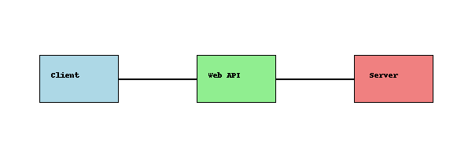
This diagram illustrates how a client sends requests to a Web API, which then interacts with a server and returns a response to the client.
This simple diagram shows how a Web API works in an easy way:
- Client: This is usually a user’s app or browser. It sends a request to do something, like get data.
- Web API: This is like a middleman. It receives the client’s request, talks to the server, and brings back the result.
- Server: This is where the actual data or action happens. It sends the response back through the API to the client.
In short, the client asks, the Web API delivers the request, the server processes it, and then the result is sent back to the client.

